Thid workbench constructed using aluminum extrusion profiles and compatible accessories, designed for industrial and workshop applications. Mainly it is used for mechatronic traing stands to be assembled on the worktable. The table is equipped with a sturdy tabletop and features modular extensions for tool mounting or additional storage.

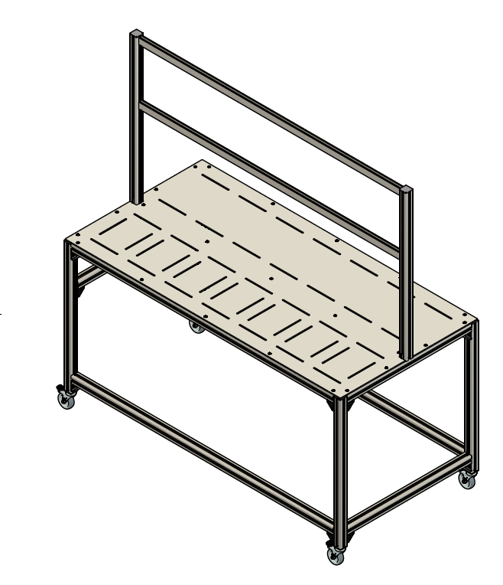
General Specifications
- Dimensions: 1600mm (W) x 752mm (H) x 720mm (D)
- Material: Aluminum profiles with steel fasteners
- Surface Finish: Signal grey powder coating
- Mobility: Equipped with four caster wheels (two with brakes)
- Modularity: Additional mounting profiles for control modules and accessories

Features and Benefits
- Durability: Constructed from high-strength aluminum profiles for robustness and longevity.
- Flexibility: Modular design allows easy customization and attachment of accessories.
- Stability: Equipped with locking caster wheels to prevent unwanted movement.
- Ergonomics: Proper height and dimensions for ease of use in industrial environments.
- Aesthetics: Clean, professional finish with signal grey components.

Applications
- Industrial workstations
- Electronic assembly tables
- Packaging and inspection stations
- Research and development labs

